Filter design (ELX III/II) Full Marks :60

  - A filter has following specification: [10]
  - Lowpass characteristics with 1 dB cut off frequency at 1 Khz
  - Minimum attenuation of 40 dB at 5 Khz
Determine the order of the filter
    - With respect to Butterworth approximation.
    - With respect to Chebyshev approximation
    - With respect to Inverse Chebyshev approximation
    - With respect to Elliptic approximation

  - Compare the magnitude and phase response of Butterworth , Chebyshev and Bessel thomson . [5]

  - Define half power point, bandwidth and attenuation. Explain how can you define types of filters from attenuation curve? [6]
  - For the circuit shown below [10]
- Derive the transfer function
- Plot the pole-zero location in s-plane
- Plot the magnitude and phase response
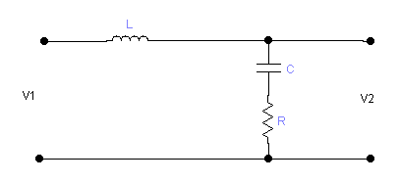

  - Synthesize LC ladder network to satisfy the following driving point impedance parameters [11]
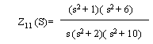
  - Transform the signal pole low pass Butter worth filter with the system function 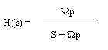into band pas filter with upper and lower cutoff frequency as Ώ _{u} and Ώ _{l} respectively. [4]
Hint: W_{O}²= Ώ _{u} * Ώ _{l} and B= Ώ _{u} - Ώ _{l}

- Write short notes: [5*3]
- Bessel-thomson method of constant delay filter design.
- The importance of magnitude and frequency scaling
- LC singly terminated network

